

Stpeps for react-native setup

By: Sadia



July 14, 2021

Perfekt SOlutions

# Steps for React-Native Setup

1) Install VS Code

Click on following link and just follow steps:

<https://code.visualstudio.com/docs/setup/windows>

2) Install Node

Click on following link and just follow steps, if you are windows user then click on windows installer, else select based on your operating system you use

<https://nodejs.org/en/download/>.

Verify installation, by checking node and npm version

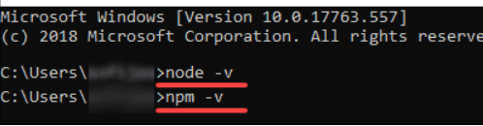

3) Install Expo CLI

Run this command to install Expo CLI globally

npm install -g expo-cli

4) Create project

Following script will create your react native project with project name **AwesomeProject**

expo init AwesomeProject

cd AwesomeProject

npm start # you can also use: expo start